**Part I**

Robotics Fundamentals

*Coursework Assignment - Sebastian Oakes*

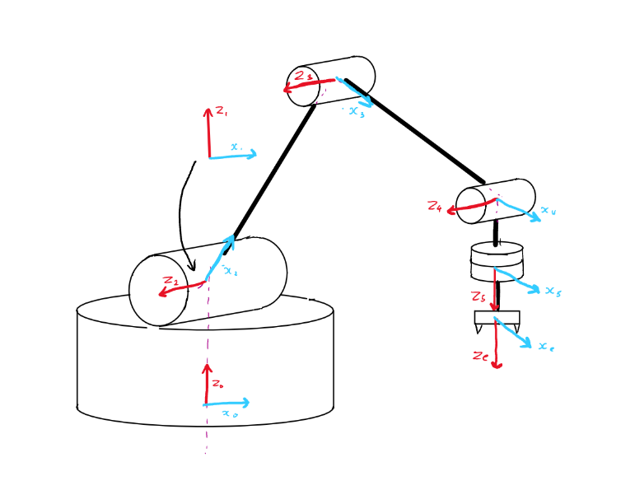

Figure 1 - Diagram representing positions of assigned frames

*D-H representation of LynxMotion arm.*

In assigning coordinate frames to the links, the proximal (modified) Denavit-Hartenberg convention was employed. A few modifications were made to the normal frame assignment process to ensure that the joint positions are accurately represented. Frame 1 was attached to the distal end of link 1 to ensure the distance from the base to the first joint was accounted for, while still allowing for the 90˚ rotation required of the 2nd frame. Frame 4 is placed with the x axis perpendicular to both Z4 and the line joining frames 4 and 5, to allow the move between frames 4 and 5 to adhere to the ordering of the D-H convention. This is best displayed in figure 1, and it is noted that a theta value of zero between frames 3 and 4 leads to an automatic 90˚angle between links 3 and 4.

The D-H parameters are displayed in table 1

|  |  |  |  |  |
| --- | --- | --- | --- | --- |
| i |  |  |  |  |
|  |  |  |  |  |
|  |  |  |  |  |
|  |  |  |  |  |
|  |  |  |  |  |
|  |  |  |  |  |
|  |  |  |  |  |